Parcel 78

1123 State St W, City of Olean

|  |  |  |  |  |  |  |  |  |  |  |  |  |  |  |  |  |  |  |  |  |
| --- | --- | --- | --- | --- | --- | --- | --- | --- | --- | --- | --- | --- | --- | --- | --- | --- | --- | --- | --- | --- |
| http://maps.cattco.org/imate/quickstream.aspx?file=VOLLOCAL/Rel2017/041200094064001100200000000005.jpg&thumb=true&width=201&height=152 | | | | | | | | | | **Status:** | | | | | | Active | | | | |
| **Roll Section:** | | | | | | Taxable | | | | |
| **Swis:** | | | | | | 041200 | | | | |
| **Tax Map ID #:** | | | | | | 94.064-11-2 | | | | |
| **Property Class:** | | | | | | 421 - Restaurant | | | | |
| **Site:** | | | | | | COM 1 | | | | |
| **In Ag. District:** | | | | | | No | | | | |
| **Site Property Class:** | | | | | | 421 - Restaurant | | | | |
| **Zoning Code:** | | | | | | - | | | | |
| **Neighborhood Code:** | | | | | | 12403 | | | | |
| **Total Acreage/Size:** | | | | | 50 x 135 | | | | | **School District:** | | | | | | Olean | | | | |
| **Land Assessment:** | | | | | 2017 - $21,300 | | | | | **Total Assessment:** | | | | | | 2017 - $95,000 | | | | |
| **Full Market Value:** | | | | | 2017 - $106,742 | | | | |  | | | | | |  | | | | |
| **Overall Eff Year Built:** | | | | 0 | | | | | **Overall Condition:** | | | | | Normal | | | | | |
| **Overall Grade:** | | | | Average | | | | | **Overall Desirability:** | | | | | 3 | | | | | |
| **AC%** | **Sprinkler%** | **Alarm%** | | | | **Elevators** | | **Basement Type** | | | | **Year Built** | **Condition** | | | | **Quality** | **Gross Floor Area (sqft)** | | | | **Stories** |
| 0 | 0 | 0 | | | | 0 | | Unfinished | | | | 1900 | Normal | | | | Average | 5576 | | | | 2 |
| **Structure** | | | **Size** | | | | **Grade** | | | | **Condition** | | | | **Year** | | | |
| Porch-covered | | | 5 × 30 | | | | Average | | | | Normal | | | | 1900 | | | |
| Porch-open/deck | | | 6 × 22 | | | | Average | | | | Excellent | | | | 2003 | | | |
| Porch-up covered | | | 6 × 16  MINIMUM BID $2500 | | | | Average | | | | Normal | | | | 2006 | | | |

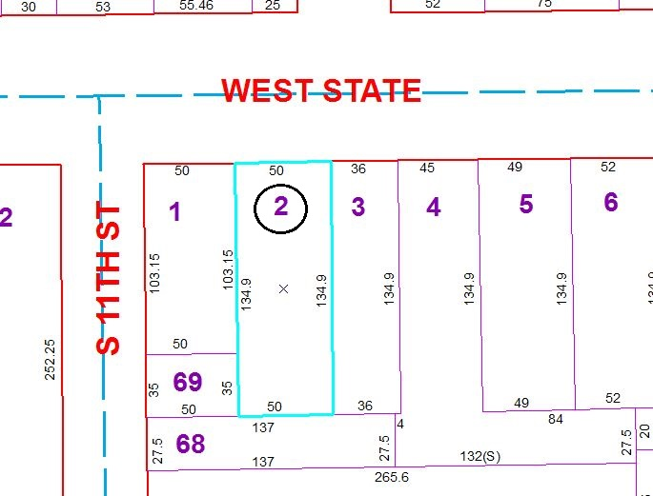

Approximate Yearly Taxes

School $2,481

City $1,384

County $1,328

Total $5,193

Special Districts for 2015