Parcel 75

 801 Sullivan St W, City of Olean

|  |  |  |  |
| --- | --- | --- | --- |
| *No Photo Available* | | **Status:** | Active |
| **Roll Section:** | Taxable |
| **Swis:** | 041200 |
| **Tax Map ID #:** | 94.064-3-11 |
| **Property Class:** | 311 - Res vac land |
| **Site:** | RES 1 |
| **In Ag. District:** | No |
| **Site Property Class:** | 311 - Res vac land |
| **Zoning Code:** | - |
| **Neighborhood Code:** | 12204 |
| **Total Acreage/Size:** | 48 x 100 | **School District:** | Olean |
| **Land Assessment:** | 2017 - $700 | **Total Assessment:** | 2017 - $700 |
| **Full Market Value:** | 2017 - $787 |  |  |

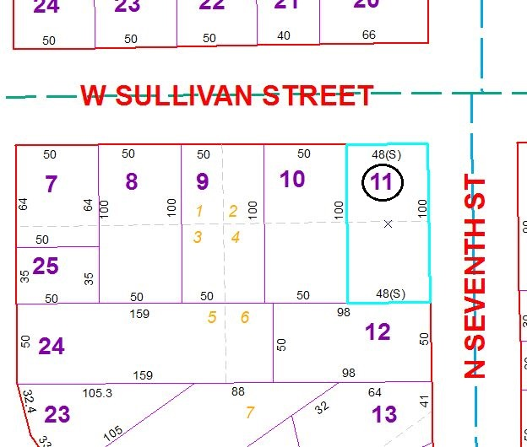

Approximate Yearly Taxes

School $18

City $10

County $11

Total $39

Special Districts for 2015