Parcel 332B

172 Beech St, Village of Gowanda

|  |  |  |  |  |
| --- | --- | --- | --- | --- |
| *NO PHOTO AVAILABLE* | | **Status:** | Active | |
| **Roll Section:** | Taxable | |
| **Swis:** | 047201 | |
| **Tax Map ID #:** | 17.029-1-16 | |
| **Property Class:** | 330 - Vacant comm. | |
| **Site:** | RES 1 | |
| **In Ag. District:** | No | |
| **Site Property Class:** | 330 - Vacant comm. | |
| **Zoning Code:** | - | |
| **Neighborhood Code:** | 72080 | |
| **Total Acreage/Size:** | 590 x 50 | **School District:** | Gowanda | |
| **Land Assessment:** | 2017 - $1,500 | **Total Assessment:** | 2017 - $1,500 | |
| **Full Market Value:** | 2017 - $2,055 | Approximate Yearly Taxes  School $35  Town/County $32  Village $25  Total $92 |  |

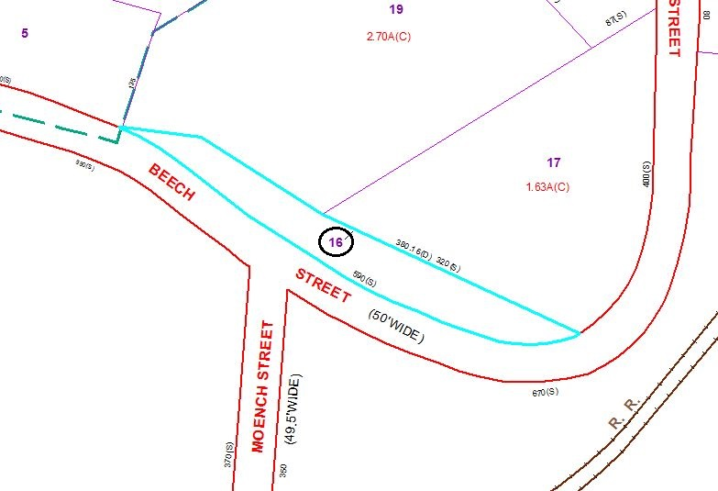

Special Districts for 2015