Parcel 304

State Land Rd, Town of New Albion

|  |  |  |  |
| --- | --- | --- | --- |
| *No Photo Available* | | **Status:** | Active |
| **Roll Section:** | Taxable |
| **Swis:** | 046489 |
| **Tax Map ID #:** | 36.003-1-10 |
| **Property Class:** | 314 - Rural vac<10 |
| **Site:** | RES 1 |
| **In Ag. District:** | No |
| **Site Property Class:** | 314 - Rural vac<10 |
| **Zoning Code:** | - |
| **Neighborhood Code:** | 64350 |
| **Total Acreage/Size:** | 3.50 | **School District:** | Cattaraugus - Little Valley |
| **Land Assessment:** | 2017 - $5,500 | **Total Assessment:** | 2017 - $5,500 |
| **Full Market Value:** | 2017 - $8,333  Approximate Yearly Taxes  School $113  Town/County $162  Total $275 |  |  |

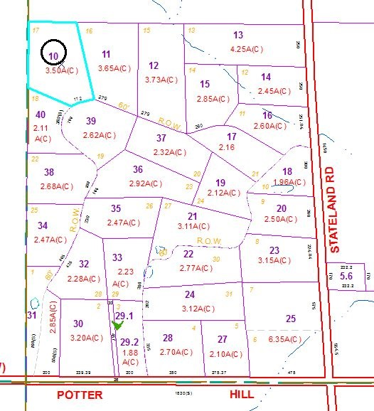

Special Districts for 2015