Parcel 300

Kings Hwy N, Town of Napoli

|  |  |  |  |
| --- | --- | --- | --- |
| *NO PHOTO AVAILABLE* | | **Status:** | Active |
| **Roll Section:** | Taxable |
| **Swis:** | 046200 |
| **Tax Map ID #:** | 62.046-2-15 |
| **Property Class:** | 311 - Res vac land |
| **Site:** | RES 1 |
| **In Ag. District:** | No |
| **Site Property Class:** | 311 - Res vac land |
| **Zoning Code:** | - |
| **Neighborhood Code:** | 62030 |
| **Total Acreage/Size:** | 208.54 x 150 | **School District:** | Randolph |
| **Land Assessment:** | 2017 - $2,200 | **Total Assessment:** | 2017 - $2,200 |
| **Full Market Value:** | 2017 - $2,340 | Approximate Yearly Taxes  School $111  Town/County $228  Total $339 |  |

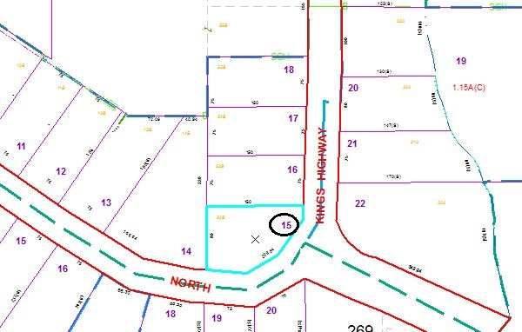

Special Districts for 2015