Parcel 275A

Byroads Rd, Town of Machias

|  |  |  |  |  |  |  |
| --- | --- | --- | --- | --- | --- | --- |
| *No Photo Available* | | | | | **Status:** | Active |
| **Roll Section:** | Taxable |
| **Swis:** | 045800 |
| **Tax Map ID #:** | 30.002-1-3 |
| **Property Class:** | 314 - Rural vac<10 |
| **Site:** | RES 1 |
| **In Ag. District:** | No |
| **Site Property Class:** | 314 - Rural vac<10 |
| **Zoning Code:** | 01 |
| **Neighborhood Code:** | 58050 |
| **Total Acreage/Size:** | 2.62 | | | | **School District:** | Yorkshire-Pioneer |
| **Land Assessment:** | 2017 - $11,400 | | | | **Total Assessment:** | 2017 - $11,400 |
| **Full Market Value:** | 2017 - $11,633  LANDLOCKED |  |  |

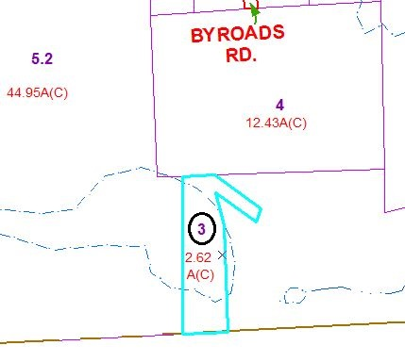

Approximate Yearly Taxes

School $154

Town/County $213

Total $367

Special Districts for 2015