Parcel 199

3529 Bakerstand Rd, Town of Franklinville

|  |  |  |  |  |  |  |  |  |  |
| --- | --- | --- | --- | --- | --- | --- | --- | --- | --- |
|  | | | | **Status:** | | Active | | | |
| **Roll Section:** | | Taxable | | | |
| **Swis:** | | 044089 | | | |
| **Tax Map ID #:** | | 39.004-2-3.13 | | | |
| **Property Class:** | | 312 - Vac w/improvement | | | |
| **Site:** | | RES 1 | | | |
| **In Ag. District:** | | No | | | |
| **Site Property Class:** | | 312 - Vac w/improvement | | | |
| **Zoning Code:** | | - | | | |
| **Neighborhood Code:** | | 40350 | | | |
| **Total Acreage/Size:** | | 20.50 | | **School District:** | | Franklinville | | | |
| **Land Assessment:** | | 2017 - $13,800 | | **Total Assessment:** | | 2017 - $43,800 | | | |
| **Full Market Value:** | | 2017 - $65,373 | |  | |  | | |
| **Structure** | **Size** | | **Grade** | | **Condition** | | **Year** |
| Barn-1.0 dairy | 72 × 63 | | Average | | Normal | | 1970 |
| Barn-2.0 dairy | 70 × 60 | | Average | | Normal | | 1920 |
| Barn-1.0 dairy | 66 × 26 | | Average | | Normal | | 1950 |
| Shed-machine | 30 × 50  Approximate Yearly Taxes  School $1,153  Town/County $1,373  Total $2,526 | | Average | | Normal | | 1975 |

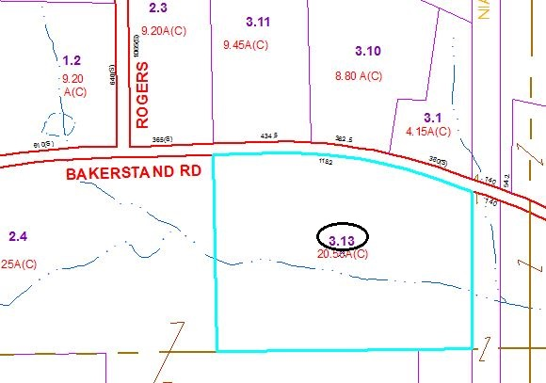

Special Districts for 2015