Parcel 162

9033 E Otto-Springville Rd, Town of East Otto

|  |  |  |  |  |  |  |  |  |  |  |
| --- | --- | --- | --- | --- | --- | --- | --- | --- | --- | --- |
| http://maps.cattco.org/imate/quickstream.aspx?file=VOLLOCAL/Rel2017/043200027016000100600000000004.jpg&thumb=true&width=201&height=152 | | | | **Status:** | | Active | | | | |
| **Roll Section:** | | Taxable | | | | |
| **Swis:** | | 043200 | | | | |
| **Tax Map ID #:** | | 27.016-1-6 | | | | |
| **Property Class:** | | 210 - 1 Family Res | | | | |
| **Site:** | | RES 1 | | | | |
| **In Ag. District:** | | No | | | | |
| **Site Property Class:** | | 210 - 1 Family Res | | | | |
| **Zoning Code:** | | - | | | | |
| **Neighborhood Code:** | | 32050 | | | | |
| **Total Acreage/Size:** | | 82.5 x 239 | | **School District:** | | Cattaraugus - Little Valley | | | | |
| **Land Assessment:** | | 2017 - $5,400 | | **Total Assessment:** | | 2017 - $55,000 | | | | |
| **Full Market Value:** | | 2017 - $55,000 | |  | |  | | | |
| **Living Area:** | | 1,380 sq. ft. | | **First Story Area:** | | | 1,016 sq. ft. | | |
| **Second Story Area:** | | 0 sq. ft. | | **Half Story Area:** | | | 364 sq. ft. | | |
| **Finished Basement:** | | 0 sq. ft. | | **Number of Stories:** | | | 1.7 | | |
| **Building Style:** | | Old style | | **Bathrooms (Full - Half):** | | | 1 - 0 | | |
| **Bedrooms:** | | 4 | | **Kitchens:** | | | 1 | | |
| **Fireplaces:** | | 0 | | **Basement Type:** | | | Partial | | |
| **Porch Type:** | | Porch-covered | | **Porch Area:** | | | 160.00 | | |
| **Overall Condition:** | | Fair | | **Overall Grade:** | | | Average | | |
| **Year Built:** | | 1900 | |  | |  | | | |
| **Structure** | **Size** | | **Grade** | | **Condition** | | | **Year** |
| Shed-machine | 18 × 25 | | Economy | | Fair | | | 1965 |
| Porch-covered | 10 × 16 | | Average | | Fair | | | 1900 |
| Porch-enclosed | 6 × 10 | | Average | | Normal | | | 1900 |

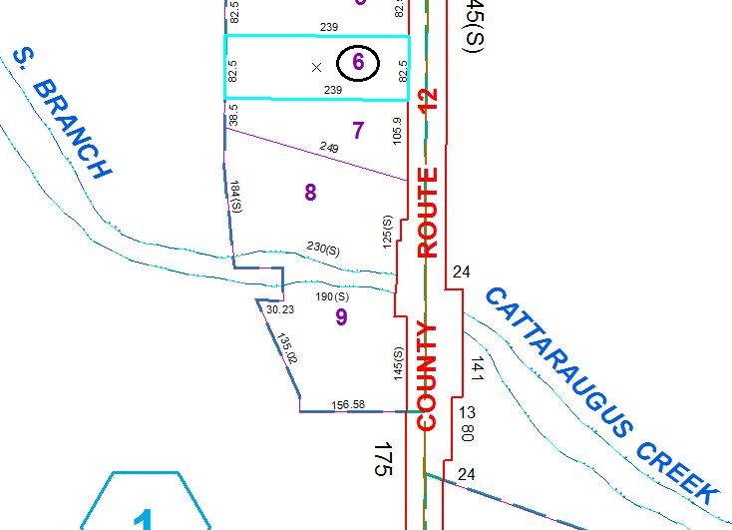

Approximate Yearly Taxes

School $803

Town/County $1,212

Total $2,015

Special Districts for 2015