Parcel 145

5315 NYS Rte. 241, Town of Conewango

|  |  |  |  |  |  |  |  |  |  |
| --- | --- | --- | --- | --- | --- | --- | --- | --- | --- |
| http://maps.cattco.org/imate/quickstream.aspx?file=VOLLOCAL/Rel2017/042800060002000202500100000006.jpg&thumb=true&width=201&height=152 | | | | **Status:** | | | Active | | |
| **Roll Section:** | | | Taxable | | |
| **Swis:** | | | 042800 | | |
| **Tax Map ID #:** | | | 60.002-2-25.1 | | |
| **Property Class:** | | | 270 – Mfg. housing | | |
| **Site:** | | | RES 1 | | |
| **In Ag. District:** | | | No | | |
| **Site Property Class:** | | | 270 – Mfg. housing | | |
| **Zoning Code:** | | | JMH | | |
| **Neighborhood Code:** | | | 28050 | | |
| **Total Acreage/Size:** | | 3.25 | | **School District:** | | | Randolph | | |
| **Land Assessment:** | | 2017 - $5,500 | | **Total Assessment:** | | | 2017 - $47,800 | | |
| **Full Market Value:** | | 2017 - $95,600 | |  | | |  | |
| **Structure** | **Size** | | **Grade** | | **Condition** | **Year** | |
| Shed-machine | 60 × 12 | | Minimum | | Poor | 1979 | |
| Gar-1.0 detached | 20 × 14 | | Average | | Fair | 1990 | |
| Mobile home | 66 × 28 | | Average | | Normal | 1993 | |

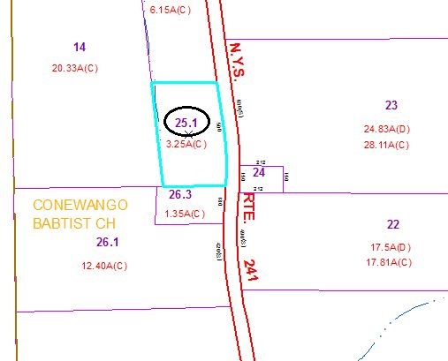

Approximate Yearly Taxes

School $931

Town/County $1,812

Total $2,743

Special Districts for 2015