Parcel 111A

NYS Rte. 240, Town of Ashford

|  |  |  |  |
| --- | --- | --- | --- |
| *No Photo Available* | | **Status:** | Active |
| **Roll Section:** | Taxable | |
| **Swis:** | 042200 | |
| **Tax Map ID #:** | 20.003-2-17 | |
| **Property Class:** | 314 - Rural vac<10 | |
| **Site:** | RES 1 | |
| **In Ag. District:** | No | |
| **Site Property Class:** | 314 - Rural vac<10 | |
| **Zoning Code:** | - | |
| **Neighborhood Code:** | 22010 | |
| **Total Acreage/Size:** | 141.8 x 100 | **School District:** | West Valley | |
| **Land Assessment:** | 2017 - $1,900 | **Total Assessment:** | 2017 - $1,900 | |
| **Full Market Value:** | 2017 - $3,519  Approximate Yearly Taxes    School $69  Town/County $58  Total $127 |  |  |

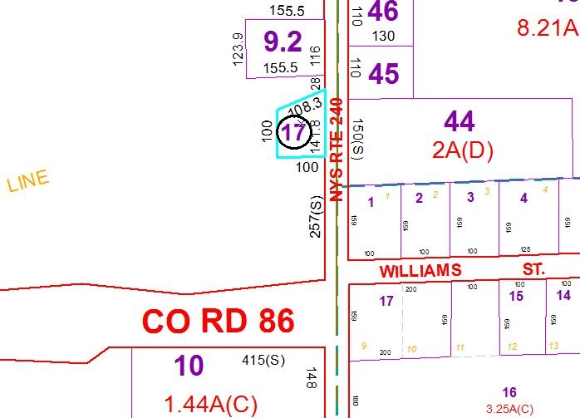

Special Districts for 2015