Parcel 78

9308 NYS Rte. 240, Town of Ashford

|  |  |  |  |  |  |  |  |  |  |  |  |  |  |  |  |  |  |  |  |  |  |  |
| --- | --- | --- | --- | --- | --- | --- | --- | --- | --- | --- | --- | --- | --- | --- | --- | --- | --- | --- | --- | --- | --- | --- |
| http://maps.cattco.org/Imate/quickstream.aspx?file=VOLLOCAL/Rel2016/042200029011000203700000000002.jpg&thumb=true&width=201&height=152 | | | | | | | | | | | | **Status:** | | | | | Active | | | | | |
| **Roll Section:** | | | | | Taxable | | | | | |
| **Swis:** | | | | | 042200 | | | | | |
| **Tax Map ID #:** | | | | | 29.011-2-37 | | | | | |
| **Account #:** | | | | | 0754 | | | | | |
| **Property Class:** | | | | | 482 – Det. row bldg. | | | | | |
| **Site:** | | | | | COM 1 | | | | | |
| **In Ag. District:** | | | | | No | | | | | |
| **Site Property Class:** | | | | | 482 – Det. row bldg. | | | | | |
| **Zoning Code:** | | | | | - | | | | | |
| **Neighborhood Code:** | | | | | 22010 | | | | | |
| **Total Acreage/Size:** | | | | | | 2.25 | | | | | | **School District:** | | | | | West Valley | | | | | |
| **Land Assessment:** | | | | | | 2016 - $6,000 | | | | | | **Total Assessment:** | | | | | 2016 - $54,100 | | | | | |
| **Full Market Value:** | | | | | | 2016 - $94,912 | | | | | |  | | | | |  | | | | |
| **Overall Eff Year Built:** | | | | 1900 | | | | | **Overall Condition:** | | | | | Normal | | | | | |
| **Overall Grade:** | | | | Economy | | | | | **Overall Desirability:** | | | | | 3 | | | | | |
| **AC%** | **Sprinkler%** | | **Alarm%** | | **Elevators** | | | **Basement Type** | | **Year Built** | | | **Condition** | | | **Quality** | | **Gross Floor Area (sqft)** | | | **Stories** | | |
| 0 | 0 | | 0 | | 0 | | | 0 | | 1900 | | | Normal | | | Average | | 7296 | | | 2.00 | | |
| **Structure** | | **Size** | | | | | **Grade** | | | | **Condition** | | | | **Year** | | | |  | | | | |
| Barn-pole | | 40 × 30 | | | | | Economy | | | | Normal | | | | 1980 | | | |  | | | | |
| Porch-covered | | 68 × 7 | | | | | Average | | | | Normal | | | | 1930 | | | |  | | | | |
| Porch-covered | | 30 × 6 | | | | | Average | | | | Normal | | | | 1930 | | | |  | | | | |
| Porch-up open | | 12 × 10 | | | | | Average | | | | Normal | | | | 1930 | | | |  | | | | |

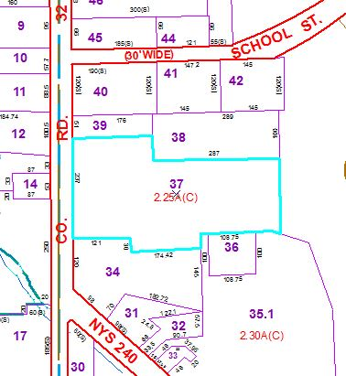

Approximate Yearly Taxes

School $2,133

Town/County $1,646

Total $3,779